Cisco Academy – Introduction to Packet Tracer

COMP 3670

October 21st, 2019

Andrea Bonato

104760390

Table of Contents

Introduction to Packet Tracer 3

What is the Cisco Online Academy? 3

What is Packet Tracer? 3

How to gain access to the course and its software? 3

Technological Details 4

The Technology 4

Packet Tracer Download and Installation Process 4

Figure 1 – “I’m Learning” page 5

Figure 1.1 – Download Page 5

Figure 1.2 – Netacad login screen 6

Packet Tracer Interfaces 6

Figure 2 – Main Blank Page for Packet Tracer 7

Figure 2.1 – Simple Network with Home Gateway Settings 7

Experience 8

Figure 3 – Chapter 2.1.1.3 of Introduction to Packet Tracer Course 9

Figure 3.1 – Chapter Breakdown of Course 10

Summary 10

Certificate of Completion 11

References 12

# Introduction to Packet Tracer

## What is the Cisco Online Academy?

The Cisco Online Academy is an online platform that assists with the development of important networking and other IT – based skills. Its general goal is to help create a more qualified workforce for future projects and jobs. The online course “Introduction to Packet Tracer” continues with the vision of improving the skill set of workers by introducing a fundamental networking tool: Packet Tracer.

## What is Packet Tracer?

Packet Tracer is an “…exciting network design, simulation and modelling tool that allows you to develop your skill set in networking, cybersecurity, and the Internet of Things….” (Chapter 1.0.1.1, Introduction to Packet Tracer) Thus generally, it is an application that allows people to study a deeper view of network models and the small details involved with them.

## How to gain access to the course and its software?

In order to gain access to not only this software, but the online course that helps develop the proficiency in this tool, one must search up <https://www.netacad.com/> on any browser, then login (or create an account). From this site, one can search through several different courses available. In this specific case, enroll in the Introduction to Packer Tracer course. From the course, one will be able to follow the instructions of the course to download the Packet Tracer software. Only after one has enrolled, then can they have access to the software. (Course chapter breakdown **figure 3.1**)

# Technological Details

## The Technology

The concept of networks originated in the year 1969 where the “first message was exchanged between [The University of California at Los Angeles] and [the Stanford Research Institute].” **2** With this creation followed the expansion of the internet and the world wide web. As the world of technology evolved, so did our ability to understand it. Cisco systems was founded in 1984 in San Jose. This company focused on the “respective computer networks using technology that other Stanford employees had devised in the 1970s….” **3** As time went by, more advanced technologies were introduced - from the basics of a router to the aspect of video conferencing. Cisco released the latest version of packet tracer on June 17th, 2016 and continues to release newer and newer versions as the era of technology develops. The next few sections will explain what Packet Tracer is, and how to access it.

## Packet Tracer Download and Installation Process

The following are the steps to download and install Packet Tracer. Note these steps are taken from chapter 1.1.2.1 in the “Introduction to Packet Tracer” course:

1. Log into <https://www.netacad.com/> , or create an account if needed. Then Proceed into the “I’m Learning” page on the Cisco Networking Academy website. As shown in **figure 1.**

### Figure 1 – “I’m Learning” page

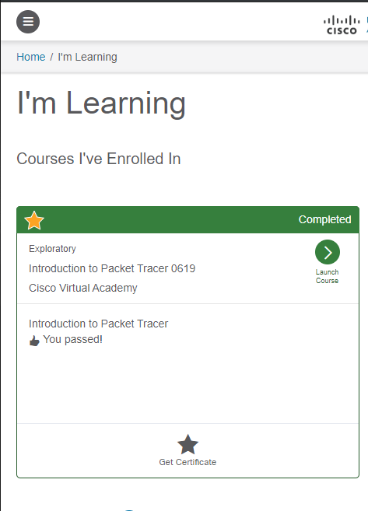

1. Select the application menu in the top right-hand corner ( ) then continue to the Resources tab.
2. Then select the Download Packet Tracer tab to be brought to the download page. You should see something similar as **figure 1.1**

### Figure 1.1 – Download Page

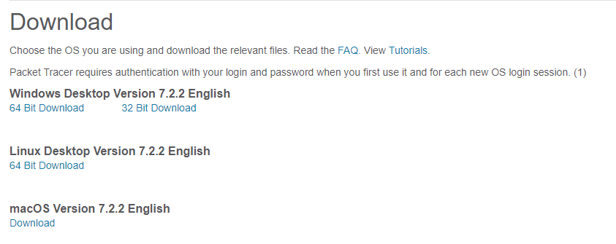

1. Choose the version to dowload, then when prompted, save onto the computer.
2. After the program finishes downloading, launch the program, follow the installation guide, restart your web browsers and then once installed, log into your Netacad account when prompted like in **figure 1.2**.

### Figure 1.2 – Netacad login screen

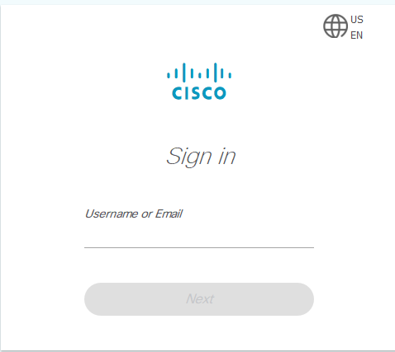

1. Done!

## Packet Tracer Interfaces

The Packet Tracer software that is offered through the Introduction to Packet Tracer course offers a bunch of different features and interfaces that allow the user to easily model and visualize networks. The following will describe some of the features and interfaces that are available within Packet Tracer. This program assists modeling networks in residential, industrial and commercial environments. In **figure 2**, the different devices that one can test with are network devices (i.e. Routers, switches, hubs, wireless devices, firewalls and WAN emulation), end devices (i.e. home, smart city, industrial, and power grid), components (i.e. actuators and sensors), connections (i.e. cabling), and multiuser connections.

### Figure 2 – Main Blank Page for Packet Tracer

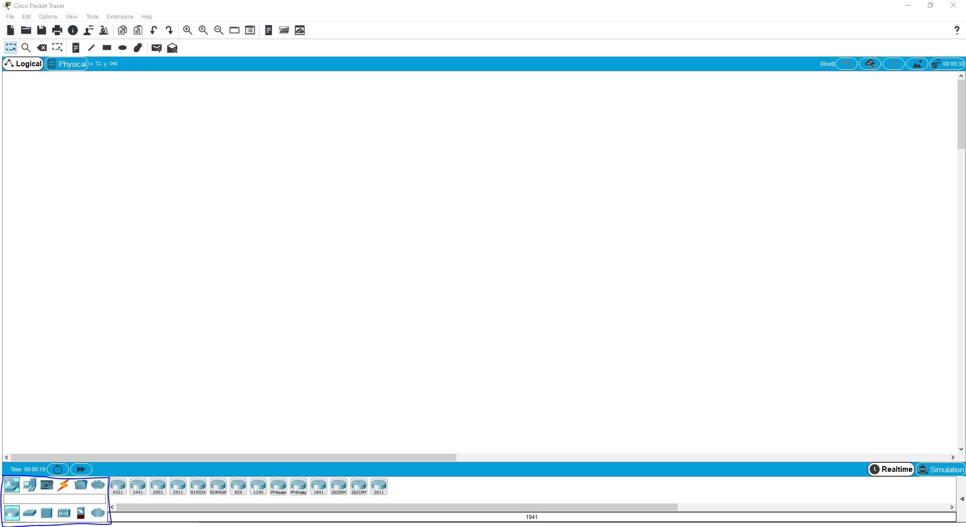

This (outlined in blue) allows you to add devices and connect them with either cables or wirelessly. Similarly, this software allows us to manage components, as well as even the small settings that the actual components would have in a real-life scenario (**Figure 2.1**).

### Figure 2.1 – Simple Network with Home Gateway Settings

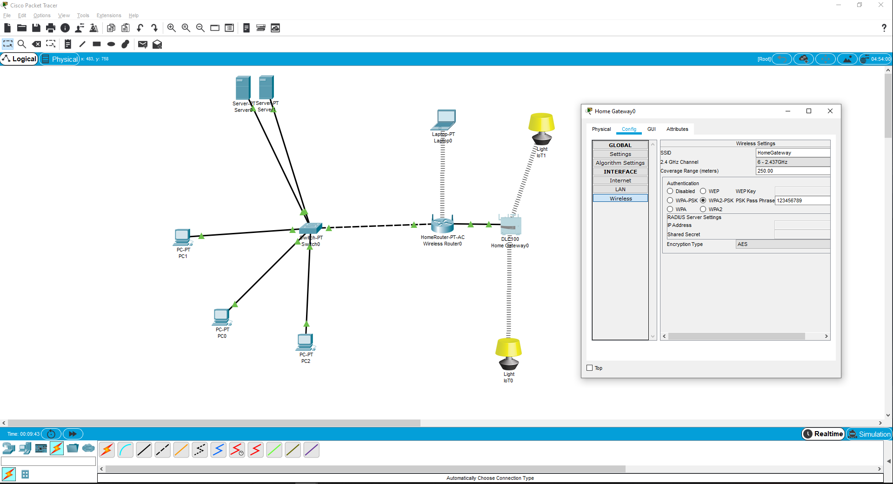

As shown in **figure 2.1**, we can access the wireless configuration of the home gateway. However, it does not stop there. We can manage ports, mechanical parts of the components and create real life representations of networks. Generally, it allows for GUI and CLI configurations.

Other interfaces that are available to the Packet Tracer software includes a simulation mode that simulates packets being sent to and from locations, a customization mode that allows the user to implement their own custom backgrounds, a physical mode that helps the user visualize what a network would look like I a real office situation and finally, a saving ability, so that users can save and load previous work for future use.

# Experience

The Cisco Online Academy is a useful tool that allows individuals to develop and gain the needed knowledge to succeed in any IT related field. One can see the benefit of this program, especially with having free courses, such as this, available to the average person. However, in my opinion, my experience felt very bipolar. More generally stated, there were many times during this online course where I had to try and reference other sources for information that could have easily been explained in order to be able to follow along with the video instructor. For example, as shown in **figure 3**, the instructor started off the video with a fully created network.

### Figure 3 – Chapter 2.1.1.3 of Introduction to Packet Tracer Course

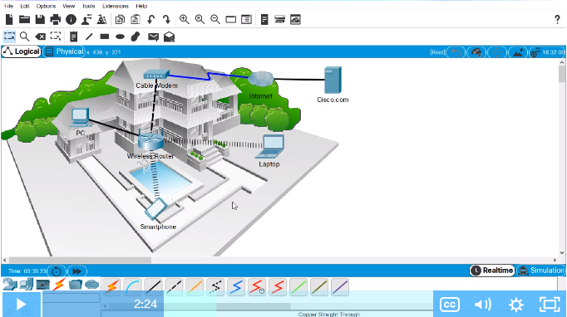

In **figure 3**, the instructor just finished explaining a lot of the features and network devices shown. However, not once did the instructor cover the modem to server setup, nor did the instructor explain how to set up an instance of a cloud that can be used for the internet. While everything else was explained thoroughly, not knowing how to set this up delayed the completion of the course when almost everything else after this depended on the modem to server setup. (I.e. Sending complex PDUs by IP Address) In a similar sense, it may have been more beneficial to be able to use already premade samples that the user following could access and use to follow along with the instructor instead of having a completely different set of network samples. In other words, it became very difficult to follow the instructor when the examples being worked with were not available to us at all. Thus, when it came to have to participate in the tests, it became difficult to match topics for the minute details that couldn’t be followed. On another hand, there were many good parts to my experience with the online program as well. For example, it was also well laid out ad organized to the point where it was easy to go back and review if necessary (**Figure 3.1**). Another example is how the labs allowed me to further practice and help refine my ability to use the Packet Tracer software. Thus, during the test, the questions that required the analysis of a network, it was a lot of fun to go into the settings and paly around with functional networks. Thus, overall, my experience with the test was very bipolar and it can overall be due to the opposite extremes (difficult vs easy) that the test took. But it did challenge my knowledge and push me to review and go over various parts in the course.

### Figure 3.1 – Chapter Breakdown of Course

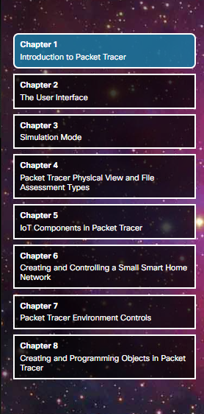

# Summary

Ever since the 1960’s the ideology of networking has expanded, and its aspects can now be seen in almost all technology. With these advancements, came the technology to model and manage networking structures, and more specifically, came the Packet Tracer software plus the online Cisco Academy. Through the online academy, one can learn about networking and all the details associated with the creation and management of a network. This course, “Introduction to Packet Tracer”, teaches the user about the software used to train individuals, or visualize a network. It assists with the simulation of networks in either the physical world or the logical one. It also helps people learn about IoT and even basic aspects of the networking world like smart home applications. Similarly, through this online course, one can gain access to, install, and use the Packet Tracer software itself. This software allows user to build, create, model and manage a visualization of networking. It includes access to almost all basic components that are used within the IT world. However, even though there were many good aspects to the course and program, some of the explanations in the course were hard to follow. This made my personal experience very bipolar during the quizzes and labs. Yet, I’d recommend this program to other people while it was still a very valued learning experience.

# Certificate of Completion

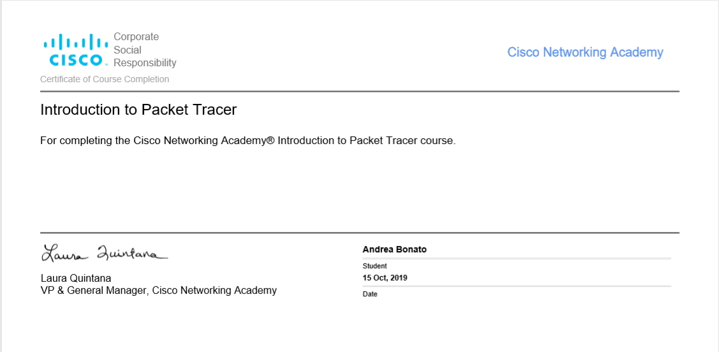

# References

1. Introduction to Packet Tracer. Cisco Virtual Academy. 2019
2. “History Of Networking.” *Tutorialspoint*, <https://www.tutorialspoint.com/communication_technologies/communication_technologies_history_of_networking.htm>.
3. Lewis, Robert. “Cisco Systems.” *Encyclopædia Britannica*, Encyclopædia Britannica, Inc., <https://www.britannica.com/topic/Cisco-Systems-Inc>.
4. A, Jesin. *Packet Tracer Network Simulator: Simulate an Unlimited Number of Devices on a Network Using Packet Tracer*. Packt Pub., 2014.
5. *z216 Improving Defense Mechanism Using Packet Tracer For ...* http://www.ijtsrd.com/papers/ijtsrd14246.pdf.